Web Time Sheet Process Through Employee Self-Service

- To begin using the Web Time Clock, first log in to Employee Self-Service. To access the
Paycom Employee Self-Service website go to www.paycom.com Then select
“Employee.”


- Enter your Username, password and the last four digits of your Social Security number. Then select “Log In.” If this is your first time logging in you will need to reset your password.
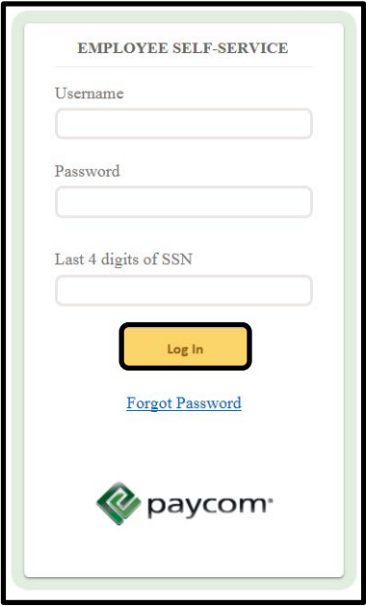

- From the main menu screen, select “Web Time Sheet” from the Time Management tile in the center of the screen or from the Main Menu navigation on the left side of the page.
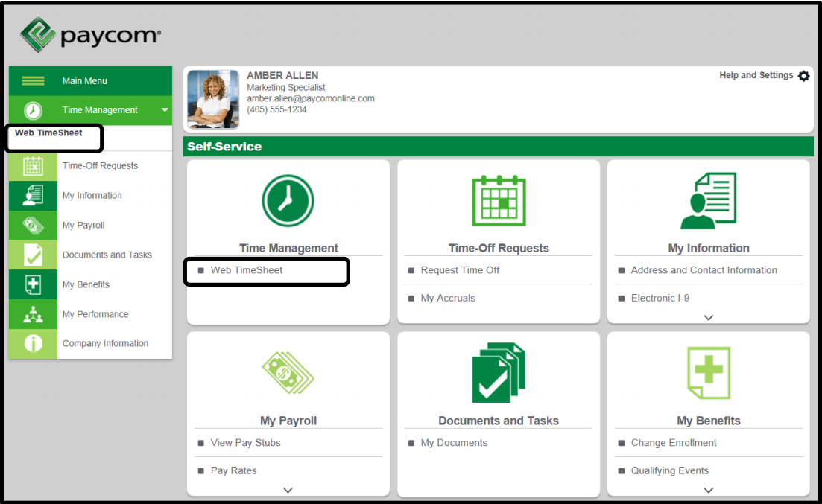
- On the Time Sheet screen, select the pay period you would like to complete the timesheet for. Then select “Add Hours”.
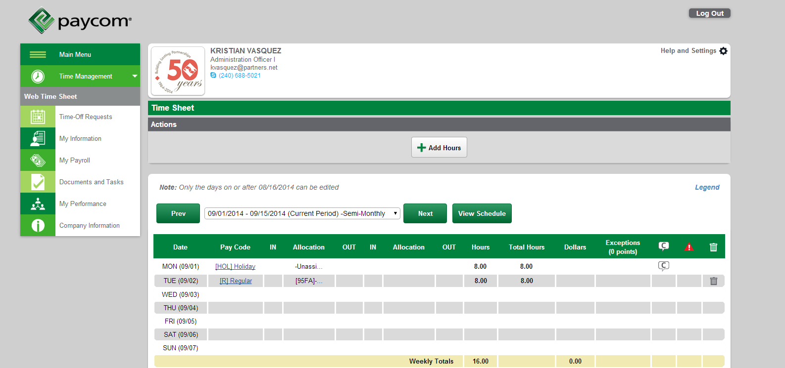

- The screen below is what you will see to add your hours to your timesheet. From here, you must:
- Select the Day(s)
- The Department to which you wish to allocate your time to
- Pay Code : Regular, Vacation, etc.
- Hours
- Comments (Optional)
If you are only charging time to an Administrative Unit you will only need to select the Department.
If you are charging time to a Grant then you must select a Department and its corresponding Grant.
When charging vacation, sick, or other leave you don’t have to select a Department or Grant.

When finished, click on the green “Add Hours” button.
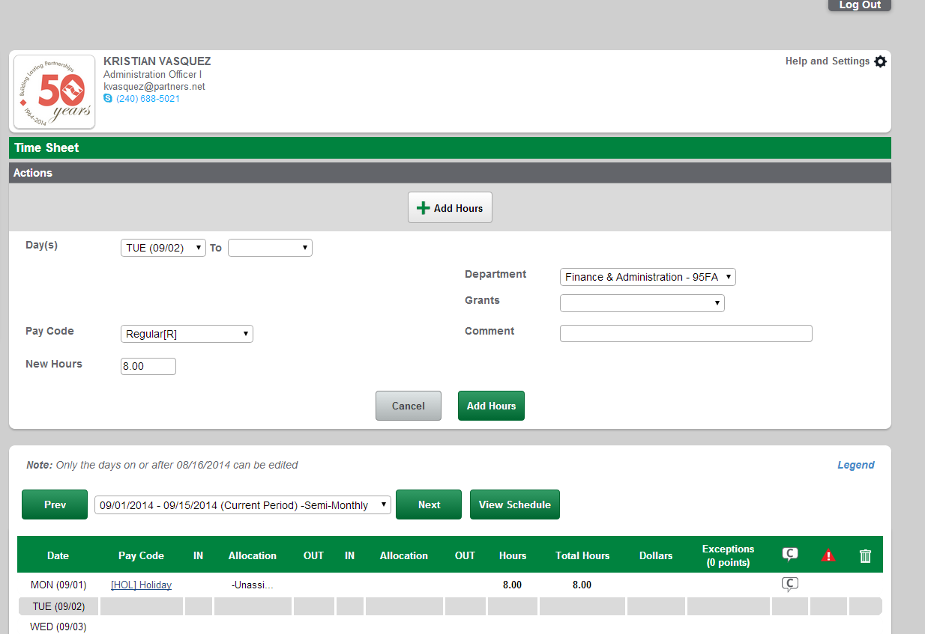

- After you’ve added your hour(s), you will see them show on your Web Time Sheet. Once you have completed your time sheet please make sure to click on the green “Approve” button.
